**FileMaker an MailChimp**

**MailChimp an FileMaker**

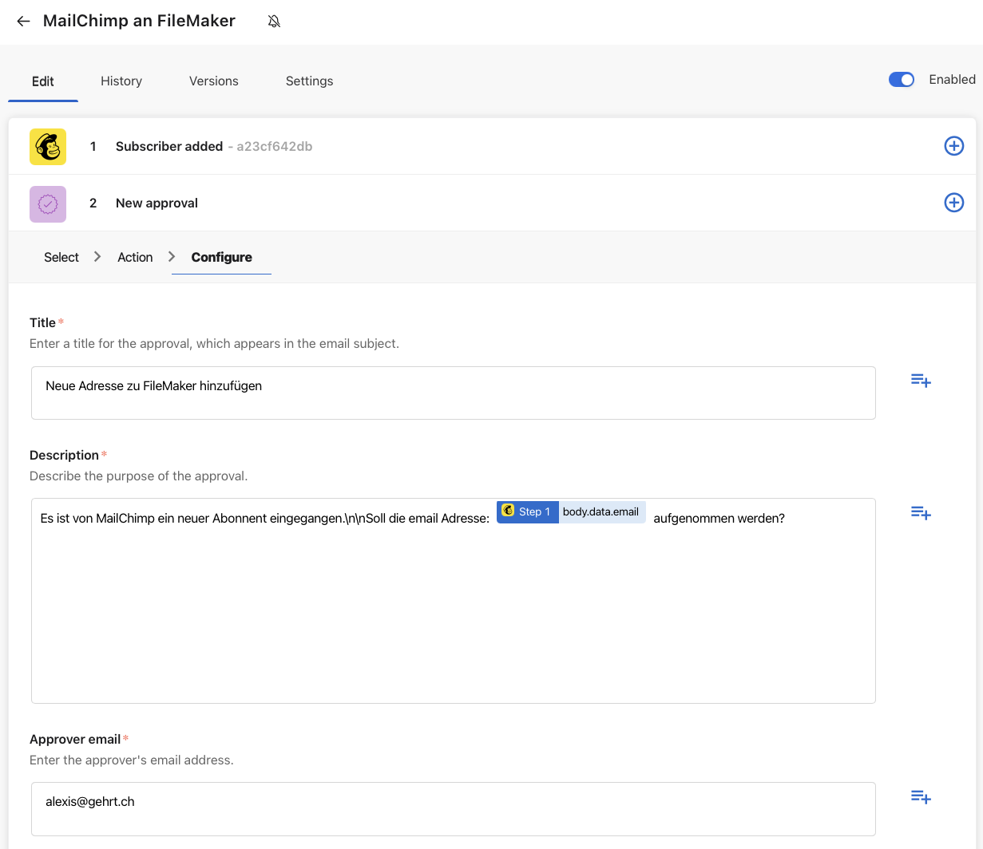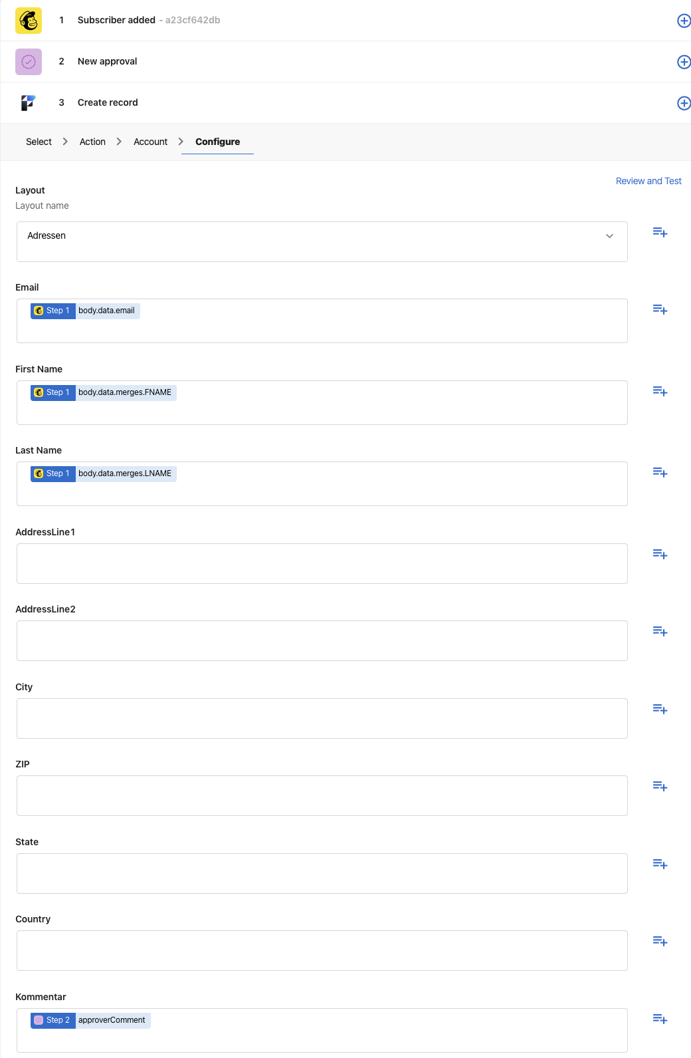

**Slack an FM**

**WebHook Beispiel**

**FileMaker Server Connector**

**